




DATA DSS Documentation

Developer: DATA DSS Limited
Author Name : DATA DSS
Author Link: https://datadss.com/
Software Framework : PHP, Laravel, JS, MySQL, Tailwind, HTML, CSS
Website: https://datadss.com/
Marketplace: Codecanyon



2024 © All Rights Reserved @ DATA DSS
DOCUMENTATION
Table of Contents
Introduction 3
Installation 4
What are the Server Requirements to install the script? 4
How to install the script on cPanel 5
How to download the latest version? 6
How to upgrade to the Latest Version? 6
Where will I find the purchase code? 7
Configuration 7
How to configure the SMTP system? 7
System Setup 9
How to Setup the website 9
How to Setup the navbar 9
How to manage the navbar 9
How to change the logo 10
How to create a new page 11
How to add contents on the home page 12
How to see the inquiries? 14
Customization 15
Theme Customization 15
Adding New Features 16
Support 16

Introduction
Welcome to the DSS Business Website documentation. This platform is meticulously crafted to cater to businesses of all sizes, whether you are a small startup, an expanding enterprise, or a well-established organization. DSS Business Website combines robustness, security, and user-friendliness to deliver a seamless solution for establishing and maintaining a strong online presence.
Built with modern, cutting-edge technology, this platform ensures reliability, scalability, and efficiency. Its developer-friendly architecture allows for effortless customization, making it adaptable to meet the unique needs of any business. With a focus on usability and performance, the DSS Business Website provides an intuitive interface that simplifies management while maintaining high professional standards.
Whether you are creating your first website or revamping an existing one, DSS Business Website is the perfect choice for achieving a polished, functional, and impactful online identity.

Installation

What are the Server Requirements to install the script?

To install the script, the minimum server requirements are:
- Php version 8.2+
- MySQL 8.0+
- MariaDB 10.3+
- mod_rewrite Apache
- BCMath PHP Extension
- Ctype PHP Extension
- JSON PHP Extension
- Mbstring PHP Extension
- OpenSSL PHP Extension
- PDO PHP Extension
- Tokenizer PHP Extension
- XML PHP Extension
- ZipArchive Extension
On most servers, these extensions are enabled by default, but you should check with your hosting provider.

How to install the script on cPanel

To install the script, follow the steps below.
- Extract the downloaded .zip file from codecanyon on your PC.
- Upload the Install.zip file to your server’s public_html or any other directory where you intend to run the script.
- Extract the zip file in that directory.
- Create a new database from your server's MySQL database.
- Create a DB user for the database and link that database to the DB user.
- First, hit your site URL and it will automatically take you to the installation.
- Click on the Start Installation Process.
- You will see the Checking File Permission page. If everything is okay, then click on Go to the next step.
- Now you need to set the Database Host, Database Name, Database Username, Database Password, and click Continue.
- Now you need to import the SQL file.
- Now fill up the information about the shop and click Continue.
Click on Go to Home/ Login to the admin panel.

How to download the latest version?

To download your item(s):
- Login to your Codecanyon account.
- Hover over your username from the top right corner and click ‘Downloads’ from the drop-down menu.
- The downloads section displays a list of all the items purchased using your account.
Click the ‘Download’ button next to the item and select ‘Main File(s)’ which contains all files, or ‘License Certificate and Purchase Code’ for the item license information only.

How to upgrade to the Latest Version?

To upgrade the latest version:
- Extract the downloaded file from codecanyon.
- There you will get a zipped folder named ‘updates.zip’. Upload that to the root directory on your server in which your previous version is running. Unzip that updates.zip file by selecting “Extract here”.
Now reload the home page

Where will I find the purchase code?

- Log into your Envato Market account.
- Hover the mouse over your username at the top of the screen.
- Click ‘Downloads’ from the drop-down menu.`
Click ‘License certificate & purchase code’ (available as PDF or text file).

Configuration

How to configure the SMTP system?

To configure the SMTP system follow the steps below:
- If you’re using cPanel then follow this link
  - https://blog.cpanel.com/setting-up-and-troubleshooting-smtp-in-cpanel

- Create an email from your server panel
- After creating an email account, go to Active eCommerce admin Dashboard > SMTP settings.
- Fill up the form as below:
  - MAIL DRIVER: SMTP
  - MAIL HOST : your domain SMTP host (sample: smtp.yourdomain.com)
  - MAIL PORT: 587/465
  - MAIL USERNAME: Your email id
  - MAIL PASSWORD : Your email password
  - MAIL ENCRYPTION: ssl/tls
  - MAIL FROM ADDRESS: Your mail address
MAIL FROM NAME: Your domain name

System Setup

How to Setup the website

- Log into your admin panel
- Click on the “Website Setting”
- You will find a page with several input fields
- Enter the information in the required fields
- After filling the information click on the “Submit” button.
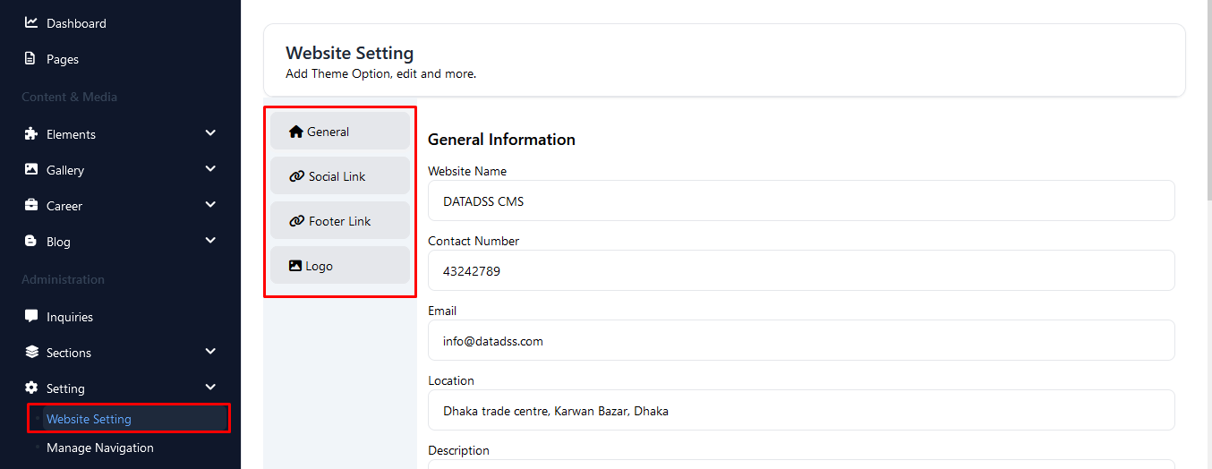
Figure 1 Website setting

How to manage the navbar

- Log into your admin panel
- Click on the “Setting”
- Go to the “Manage Navigation”
- Drag and drop the menus
- After proper alignment click on the “Update” button.
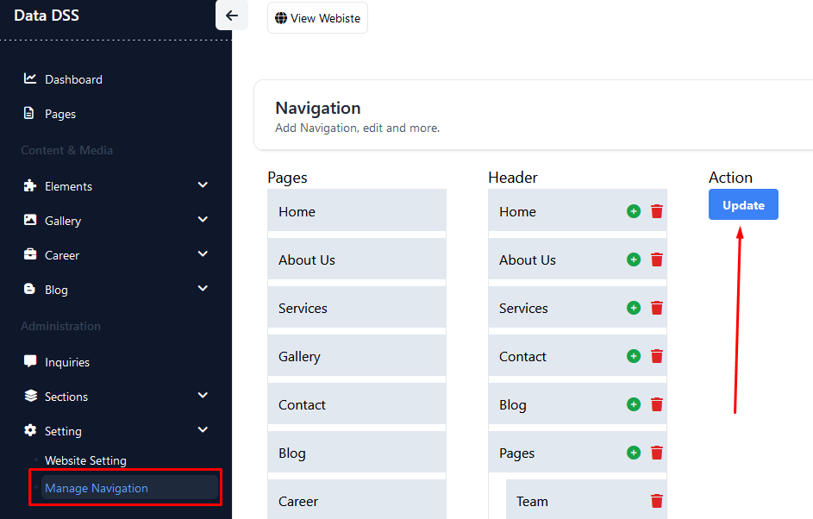
Figure 2 Manage Navigation

How to change the logo

- Log into your admin panel
- Click on the “Setting”
- You will find the logo change page in “website setting”
- Upload the logo
- After uploading the logo click on the “Submit” button.

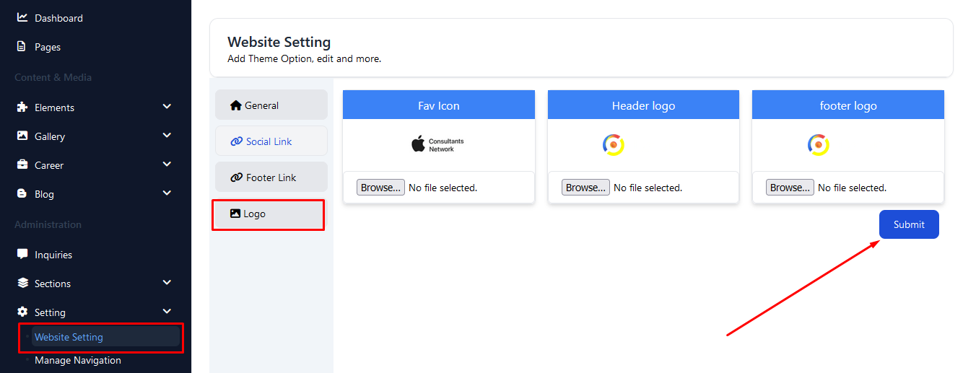
Figure 3 Logo change option

How to create a new page
- Click on the “Pages” menu in left sidebar
- “Add Page” is the button for creating new page
- Fill the required field
- You will find two options
- Click on the “save” or “save and exit” button
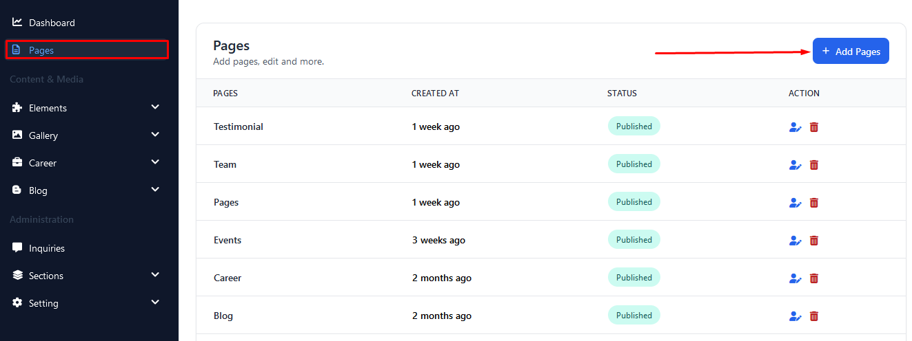
Figure 4 Create new page button
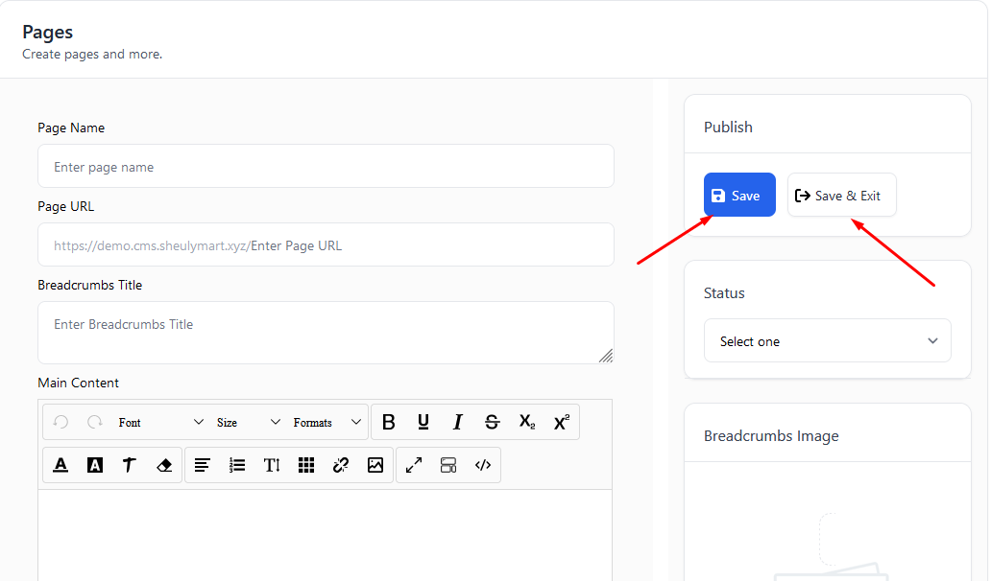
Figure 5 Create page

How to add contents on the home page
- Click on the page edit option
- “Add UI Block” button will show available components
- Select the desired component
- Give information in the input fields
- You will find two options
- Click on the “save” or “save and exit” button

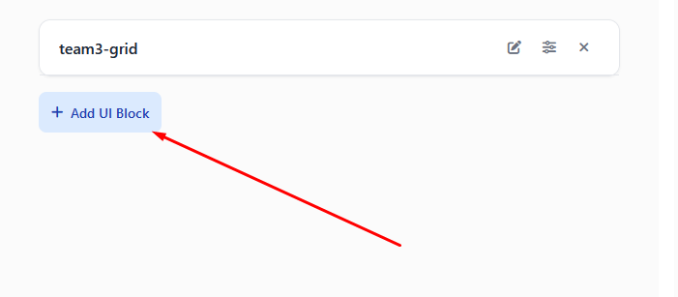
Figure 6 Click on the "Add UI Block"
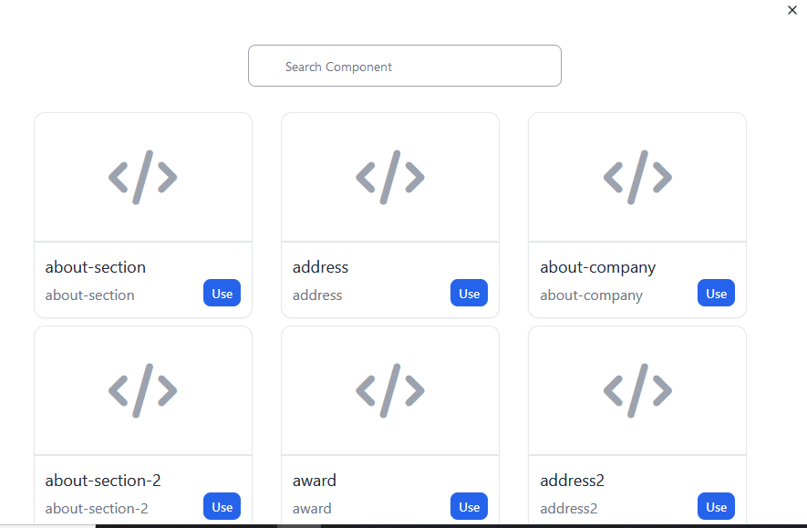
Figure 7 components for page

How to see the inquiries?

- Click on the “Inquiries” button
- You will see the inquiry that people sent
- You can see all of the inquiries by clicking on the “View All” button.

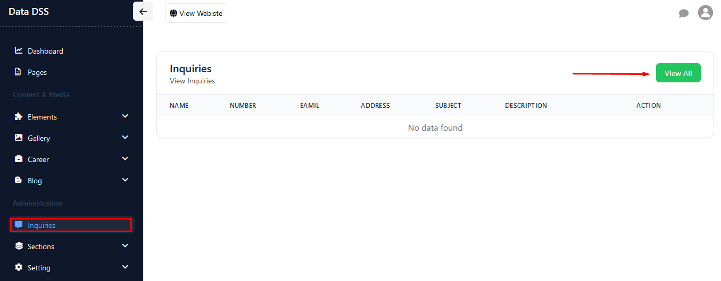
Figure 8 Inquiries list

Customization

Theme Customization

To make your experience seamless and flexible, we have provided various settings that you can modify directly from the admin panel. This includes options such as color changes and other configurations, allowing you to tailor the website's appearance and functionality to your preferences without altering the source code.
Additionally, we provide access to the full source code, enabling you to customize the application as per your specific requirements. If you choose to customize the code, our support team is available to guide you through the process and offer assistance where needed. We are committed to helping you achieve the desired outcome while using our platform.
Important Note:
Please be aware that once the script is customized, it will no longer be covered under our standard support policy. Customizations also prevent future updates to the application, as applying an update will overwrite your customizations and result in their loss.
For this reason, we encourage you to carefully plan any customizations and ensure they align with your long-term requirements. Our team is always ready to assist you and provide advice to make the customization process as smooth as possible.

Adding New Features

Please note that adding new features is not covered under our standard support policy. However, we are here to assist you with solutions for incorporating additional features into your DSS Business Website. You have the flexibility to either hire your own developer for customization or engage our team of experts for this purpose.
It is important to understand that once the script is customized, it no longer falls under our support policy. This means that any updates or support provided for the original script may not apply to your customized version. Additionally, if you attempt to update the application after customization, the changes made during customization will be overwritten, and you may lose the custom features.
To avoid complications, we recommend careful planning and consideration before proceeding with customizations. Our team is available to guide you through the process and ensure that your needs are met effectively and efficiently.

Support

If you encounter any technical issues or discover any bugs while using DSS Business Website, we encourage you to inform us at developer.datadss@gmail.com. Your feedback is invaluable, as it helps us maintain and improve the quality of our platform.
Please note that during periods of high support demand, it might take longer than usual to respond to your queries. We kindly ask for your patience and understanding as we work diligently to address each request. Rest assured, every concern is important to us, and we are committed to resolving your issues as quickly and efficiently as possible.
Our dedicated support team is here to assist you and ensure that your experience with DSS Business Website is seamless and satisfactory. Thank you for your trust in our services, and we look forward to helping you achieve success with your online presence.

